 | Personal relationships are very important to people with learning disabilities.
 | We would like every organisation that signs the Charter to have relationships guidance.
 | Adults with learning disabilities have the same feelings and sexual needs as everyone else.
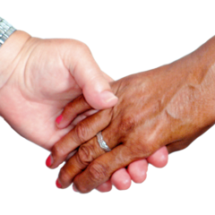 | But some people with learning disabilities need support with their relationships.
 | Relationships guidance will help staff and carers to give the right support.
The Welsh Government says adults with learning disabilities should –

- Have the right to sexual relationships with other adults.
- Have independence and be able to make their own choices.
- Feel included in their local community

The Equalities Act says that people’s gender and sex identity should be respected.

And that LGBTQ relationships should be respected.

This is just as true for people with learning disabilities.

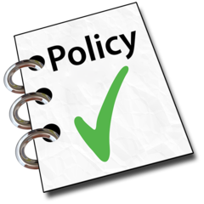 | So, it is important that a relationships policy includes this.
There are many different types of relationships.
From committed partnerships to casual hook ups.
People’s choices in these should be respected.

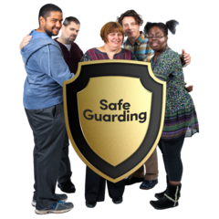 | The Welsh Government says that staff supporting people with learning disabilities must protect them from harm.  So, organisations need a good Safeguarding Policy.  The policy should be accessible to people with learning disabilities.
People with learning disabilities say –

“We want help with our relationships sometimes”.

“The individual person or couple should be encouraged to make their own decisions – with information and advice if needed – but not to be told what to do.”

“We want help with contraception (when you don’t want to have a baby)”.

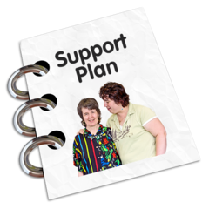 | Should staff tell you what to do?  - Staff should not tell you what to do.  - But they can help you to make a decision.  - They can give you information.
When should staff get involved?

- If you are unable make your own decision.
- If they think you are in danger.
- If you are unhappy.
- If they see signs that the relationship might be hurting you.

 | Abuse can be in many different forms – physical, sexual, emotional, financial or neglect. We want staff to be alert to them all.
When should staff get involved?
- If people are having more than a kiss or cuddle in public.
- If you need advice about having a baby.

 | This is what staff should do.
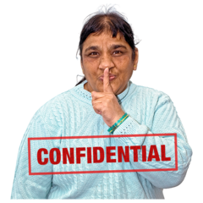 | - Support people to make good relationships and support people with ways to start relationships.  - Make sure people are not being hurt by the relationship.  - Keep things private about the relationship.  - Tell the manager if someone is at risk.  - Support people to talk about family and friends who can help them.  - Have training to give the right support.  - Give information about keeping safe and what is right and wrong.  - Tell people if they are behaving in an embarrassing way in public.  - Put the person first, not the person’s family.
X | This is what staff should not do.
- Tease people about how they look.
- Tease people about their choice of partner.
- Have sex with someone they support.
- Push people to have a relationship they are not ready for.
- Ever talk about relationships out of work.
- Try to stop people having a relationship.

